Documentation

  - Grid-based movement controller

Contents
Description. 2
Key features. 3
Grid-based movement system. 4
Scene set up. 7
Level elements implementation. 8
Script reference. 13

Description.

The purpose of this tool is to provide a head start for the development of grid-based dungeon crawler games.
The "Grid-based movement controller" provides the basic functionality of a first-person grid-based movement system. It features a grid system based on a responsive grid unit called a "Tile." The grid system allows for decoupling of tile mechanics from its model, if necessary, and the ability to design the level art style separately from the grid. Each tile on the grid can be dynamically switched as walkable or not, depending on the level design.

Key features.

This tool can be used for developing first-person grid-based dungeon crawlers and similar games.
A sample level demonstrates the implementation of various elements, such as:
• Stairs
• Elevators and moving platforms
• Ladder
• Tunnel (crouching mechanics)
• Dynamic obstacle (door)
• Hidden path
• Teleportation
All these elements utilize the grid system, which separates the design of player movement from the logic of the level elements. The player's movement mechanics rely solely on the grid system and are not dependent on the specific level elements. This allows for the implementation of additional elements without needing to modify the player's movement logic.
This is not an exhaustive list, as other level elements can also be implemented using this approach.

Grid-based movement system.

The core element of the grid-based system is a grid unit called a "Tile." Each Tile is a game object with the tag "Tile" and includes the following components:
- Box Collider Component: The Tile has a box collider component, which provides the physical boundaries for the Tile object.
- Triggers: There are four triggers in each direction (forward, back, left, and right) that detect neighbouring tiles on the grid. These triggers facilitate movement and interaction between adjacent Tiles.
- Central Trigger: In addition to the directional triggers, there is a central trigger that detects obstacles within the Tile. This allows for obstacle detection and handling within the grid system.
By utilizing these components, the Tile serves as the fundamental building block for the grid-based system, enabling movement and interaction between tiles and handling obstacles within the grid.

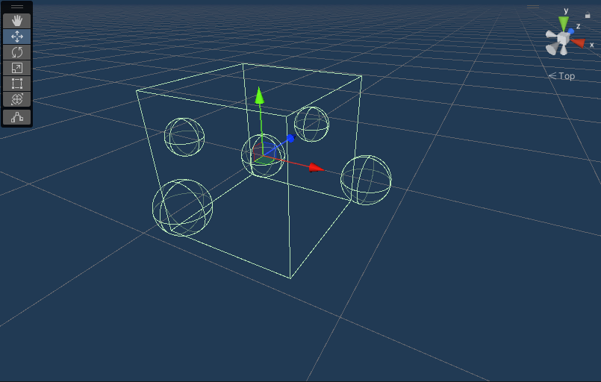
Pic 1 – Tile prefab view.

Each Tile object has a child object called "Triggers" that includes four directional triggers and one obstacle trigger:
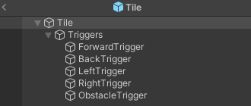
Pic 2 – Tile object hierarchy.
A model of the floor could be added as a child object of the Tile, if necessary.
Each Tile object has the following components:
- Box Collider Component: This component has the “Is Trigger” checkbox enabled, and it is required to define the scope of the Tile.
- Rigidbody Component: This component has the “Is Kinematic” checkbox enabled, and all Constraints checkboxes are also enabled. It is required to detect collider trigger events.
- TileCore and TileController Components: These components are required to handle navigation on the grid. For more details, please refer to the class reference.
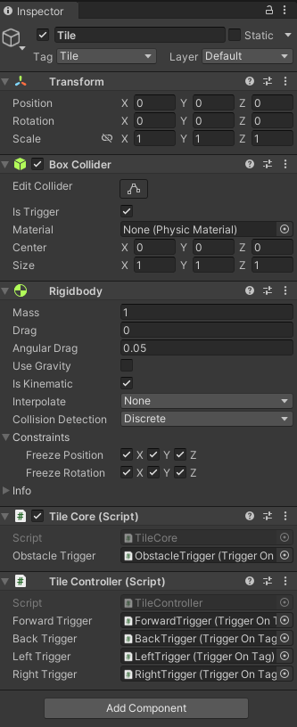
Pic 3 – Tile object components.

Each of the four directional triggers of the Tile object has a TriggerOnTag component with a Trigger Tag set to "Tile" and a Sphere Collider component with the “Is Trigger” checkbox enabled.
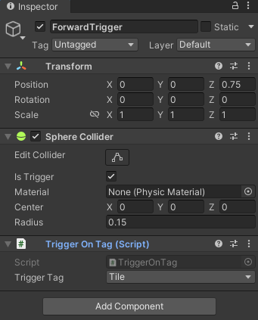
Pic 4 – The Forward Trigger component (similar for the other directional triggers with varying sphere collider position values)
The Obstacle Trigger of the Tile object has the Trigger Tag set to "Obstacle". For more details on the TriggerOnTag component, please refer to the class reference.
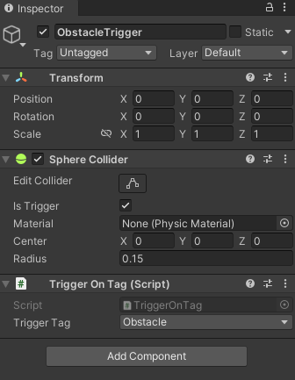
Pic 5 – Obstacle Trigger components.

Scene set up.

- Create Tags named “Tile” and “Obstacle”:
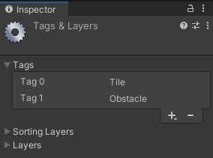
Pic 6 – Required additional tags.
- Set up a level by either using the Tile prefab from the sample scene or creating a new Tile with the components explained in the grid-based movement system section. Create various elements within the level.
- Create a Player game object and make the Main Camera a child object of the Player game object.
- Attach the PlayerCore, PlayerController, and Capsule Collider components to the Player game object. Set the starting tile of the grid to the "Grid" property of the PlayerController component. Adjust parameters within the PlayerController component and assign movement keys in the PlayerCore component:

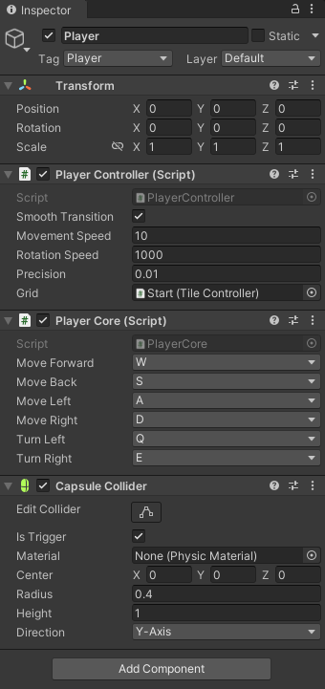
Pic 7 – Player game object’s components set up.

Level elements implementation.

- Stairs
Each tile is shifted along the Y-axis, but the trigger still intersects with the box collider of the next tile. As a result, the player controller will move towards the position of the next tile, which is elevated by a delta Y value relative to the current tile:

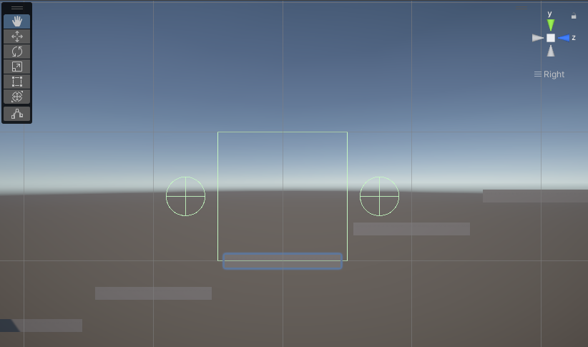
Pic 8 – Tile collider with its Forward and Back triggers.
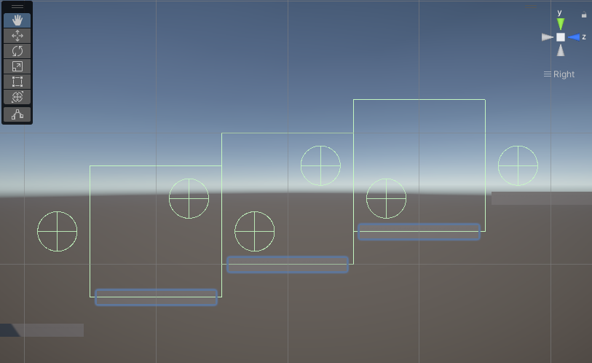
Pic 9 –Forward and Back triggers intersections with adjacent tile colliders.

- Ladder
Ladder in a sample level example requires adjusting the positions of the ForwardTrigger and BackTrigger.
For each tile of the ladder, the positions of both the Forward and Back triggers should be adjusted to intersect with the next adjacent tile vertically, instead of horizontally like the rest of the tiles on the grid. This adjustment enables the player to move vertically when transitioning to the next tile.

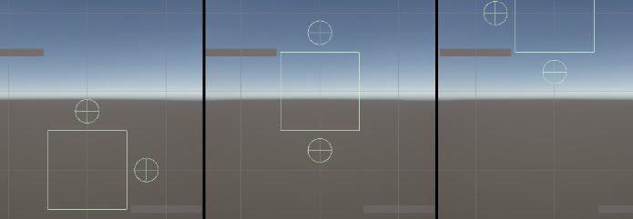
Pic 10 – Ladder tiles: Tile colliders with Forward and Back triggers.

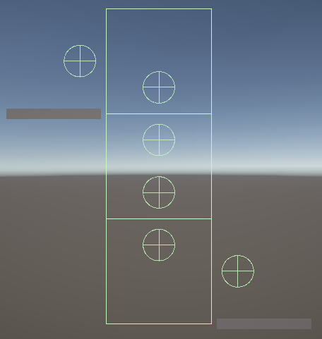
Pic 11 – Forward and Back triggers placement in the ladder and their intersections with adjacent vertical tiles.

- Obstacle
When an obstacle touches the obstacle trigger (sphere collider) of a tile, the main collider (box collider) of the tile disappears. This causes adjacent tiles to be unable to "see" this tile, resulting in their inability to provide the player with the position of the next tile. Consequently, the player cannot move towards the next tile.

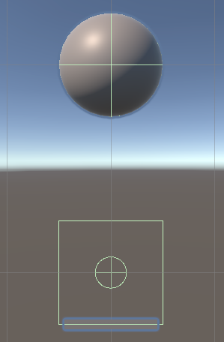
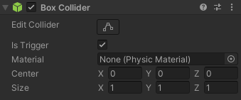
Pic 12 – Obstacle and tile interaction. Tile is “walkable”.
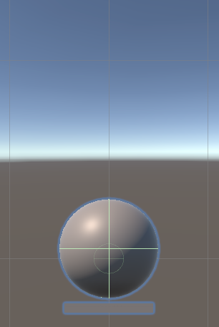
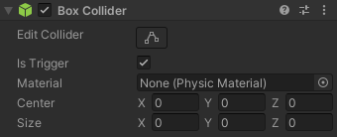
Pic 13 – Obstacle and tile interaction. Tile is not “walkable”.

- Hidden Path
Obstacle mechanics can also be utilized for walls, doors, hidden rooms, or hidden paths that can be accessed under certain conditions (e.g., a player casting a spell to fly over water tiles). These mechanics provide versatility in level design.
In the sample scene, a hidden path is provided as an example of such a level element. When the player is next to the hidden path and presses the spacebar, it opens a path across the gap on the grid. For detailed information, please refer to the script reference.
The hidden path is a game object tagged as "Obstacle" with a Tile set as its child object. To open the path, the box collider of the hidden path object should be raised above the obstacle trigger of the tile, allowing the tile to become "walkable.":

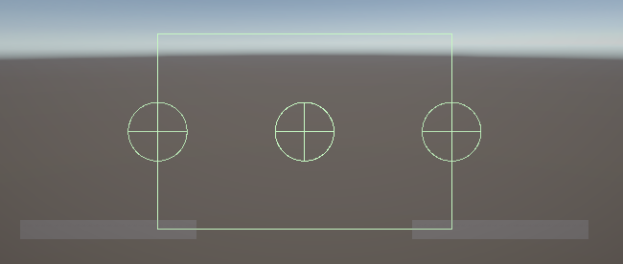
Pic 14 – Hidden Path. Tile “unwalkable”.
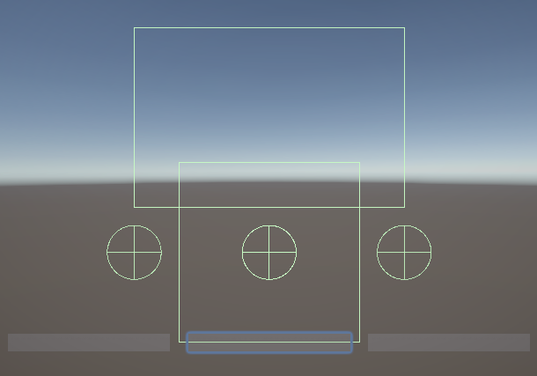
Pic 15 – Hidden Path. Tile “walkable”.

- Tunnel
The inner tiles of the tunnel have shorter main colliders, rendering them unwalkable for the outer tiles:
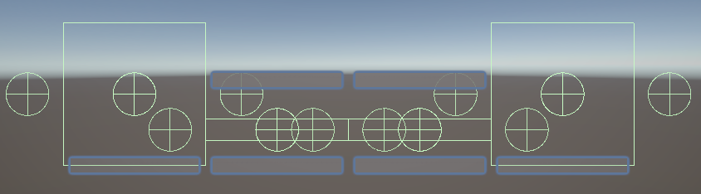
Pic 16 – Tunnel. Inner tiles “unwalkable” for the outer tiles.
To traverse through the tunnel, the outer tile of the tunnel needs to descend so that its trigger can reach the collider of the first tile within the tunnel. This allows it to be recognized as the next walkable tile. Once the player crouches inside the tunnel, they will follow the tunnel's design based on the grid:
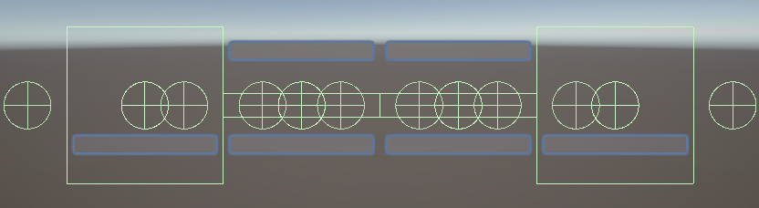
Pic 17 – Tunnel. Inner tiles “walkable” for the outer tiles.
- Moving platforms
Moving platforms utilize the Tile grid unit. The player can step on and off the platform only if they are standing on a grid tile that is in close proximity to the platform, allowing the player to identify it as an adjacent tile:
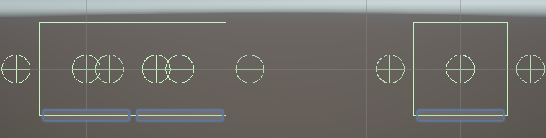
Pic 18 – Horizontal moving platform. The platform is “walkable” for the left Tile and “unwalkable” for the right Tile.
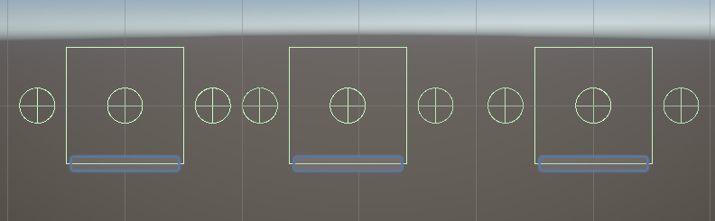
Pic 19 – Horizontal moving platform is “unwalkable” for both left and right Tiles.
A vertical moving platform can be designed in a similar manner. For an example of its implementation, please refer to the sample scene.

- Teleportation
Teleportation mechanics utilize the ControllerOverride component of the PlayerController. It overrides the targetTile field of the PlayerController component with the "Teleport To" Tile. The ControllerOverride component also provides functionality to override movement speed and can be used in other scenarios when the Player game object needs to be taken control of.

In the demo scene, teleportation is implemented as follows: The teleport game object has a TeleportController component that handles teleportation logic, a TriggerOnTag component, and a sphere collider that can identify if the player is in close proximity to the teleport game object. The TeleportController has a "Teleport To" field, which should be a "TileController" tile. When the player presses "Space" while being in close proximity to the teleport game object, it will use the OverrideTargetTile method of the ControllerOverride component to perform teleportation.

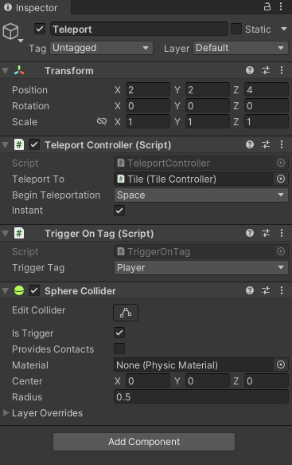
Pic 20 – Teleport game object components.

Script reference.

Navigation
Classes
TileCore
Description
This component defines a tile. Each Tile game object should have this component. It includes an obstacle collider that triggers when an "Obstacle" tag is detected. The tile is considered "unwalkable" when an obstacle is detected.
Properties
obstacleTrigger | refers to the TriggerOnTag component, which will have its "IsTriggered" property set to true if an object with the tag "Obstacle" intersects its collider.

Fields
tileCollider | main collider of the Tile object.
colliderDefaultSize | default size of the main collider.

Private Methods
Start | initializes the tileCollider and colliderDefaultSize.
Update | adjusts the size of the tileCollider based on the "IsTriggered" property of the obstacleTrigger.

TileController
Description
This component provides the functionality for grid-based movement. It includes four triggers that represent the four directions. When the player moves in a specified direction, it returns the adjacent tile object.
Properties
forwardTrigger | refers to the TriggerOnTag component of the “Forward” trigger object.
backTrigger | refers to the TriggerOnTag component of the “Back” trigger object.
leftTrigger | refers to the TriggerOnTag component of the “Left” trigger object.
rightTrigger | refers to the TriggerOnTag component of the “Right” trigger object.

Public Methods
GetTile | returns the adjacent tile based on the provided parameter "direction".

Private Methods
ForwardTile | returns the TileController component of the adjacent tile in the forward direction if the property "IsTriggered" of the forwardTrigger is true. Otherwise, it returns itself.
BackTile | returns the TileController component of the adjacent tile in the back direction if the property "IsTriggered" of the backTrigger is true. Otherwise, it returns itself.
LeftTile | returns the TileController component of the adjacent tile in the left direction if the property "IsTriggered" of the leftTrigger is true. Otherwise, it returns itself.
RightTile | returns the TileController component of the adjacent tile in the right direction if the property "IsTriggered" of the rightTrigger is true. Otherwise, it returns itself.

Enumerations
Direction
Description
keeps the directions with their corresponding Euler degrees values.
Properties
Forward | 0 degrees
Left | 270 degrees
Back | 180 degrees
Right | 90 degrees
Round | 360 degrees

Player
Classes
PlayerCore
Description
Defines the movement keys and requires the PlayerController component.
Properties
moveForward | defines the key code for stepping forward
moveBack | defines the key code for stepping back
moveLeft | defines the key code for stepping forward left
moveRight | defines the key code for stepping forward right
turnLeft | defines the key code for turning left
turnRight | defines the key code for turning right

Private Methods
Start | initializes the PlayerController component.
Update | executes methods of the PlayerController component based on the pressed key.

PlayerController
Description
This component utilizes the grid to enable movement and rotation functionality.
Properties
smoothTransition | defines whether the player's movement and rotation are instant or not.
movementSpeed | defines the movement speed.
rotationSpeed | defines the rotation speed.
defaultTransition | keeps the default transition value.
defaultMovementSpeed | keeps the default value for the “movementSpeed” field.
precision | defines the precision with which the player should be placed on the Tile's position
grid | defines the start tile of the grid.
IsBusy | this property is set to true when the player is moving or rotating.

Fields
currentDirection | represents the direction the player's camera is facing and is defined by the enumeration "Direction".
targetTile | represents the next tile that the player should move towards.
TargetRotation | represents the rotation that the player should rotate towards.

Private Methods
Start | Initializes defaultTransition and defaultMovementSpeed values, initializes the currentDirection field as "Forward", the targetTile field as the grid parameter, and the targetRotation based on the value of the currentDirection.
Update | executes the Move and Rotate methods if the IsBusy property is true, indicating that the targetTile has been assigned but not yet reached or the targetRotation has changed but not yet reached.
Move | moves the player towards the position of the targetTile.
Rotate | rotates the player towards the Euler angles of the targetRotation.
LocalDirection | returns the direction relative to the current direction based on the provided parameter. For example, if the currentDirection is "Left" and the parameter direction is "Left", it returns "Back".

Public Methods
MoveTowards | reassigns a new targetTile based on the provided "direction" parameter relative to the current direction.
RotateTowards | reassigns the currentDirection based on the provided "direction" parameter relative to the current direction.

ControllerOverride
Description
This component is complementary to the PlayerController component and has functionality to override its fields. It is implemented as a partial class called "PlayerController."
Public Methods
ResetOverrides | resets movement speed and transition fields to their default values.
OverrideTransition | overrides smoothTransition field with the provided new value
OverrideMovementSpeed | overrides movementSpeed field with the provided new value
OverrideTargetTile | overrides targetTile field with the provided value

Helpers
Classes
TriggerOnTag
Description
This helper component has a state "IsTriggered" when detecting a specified tag. All tags should be specified in a Tag enum. It is used by TileController to identify adjacent tiles, with the tag "Tile" specified for that purpose. It can also be used by other components to identify proximity with an object of a certain tag.
Properties
triggerTag | defines the tag that should set the state of the component to "IsTriggered".
IsTriggered | defines the state of the component. It is set to true if the gameobject's collider intersects with a collider of an object with the specified tag.
TriggerObject | refers to a game object with the specified tag that intersects with this component's game object.

Private Methods
OnTriggerEnter | sets "IsTrigger" to True if the component interacts with an object of the specified Tag, and saves the object as the TriggerObject property.
OnTriggerExit | sets "IsTrigger" to False if the component stops interacting with an object of the specified Tag, and assigns null to the TriggerObject property.

Enumerations
Tag
Description
This enumeration keeps the tags that can be referenced in the code.

Level
Classes
HiddenPathController
Description
hides or reveals the path by descending elevating the main collider over the obstacle collider of the tile.
Properties
maxElevation | represents the relative elevation value for the y-coordinate of the main collider.
revealPath | represents the key code that triggers the hiding/revealing of the path.
revealTileModel | refers to the model of the tile that will be revealed.

Private Methods
Start | initializes a TriggerOnTag component, the reveal collider (which is the main collider assigned to the object tagged as "Obstacle"), and the default position of the reveal collider.
Update | holds the functionality for hiding and revealing the path.

CrouchController
Description
The CrouchController component descends the position of the assigned Tile.
Properties
crouch | the KeyCode that triggers the Descent functionality
descension | the y value of the relative descension of the Tile's position.

Private Methods
Descent | descends the game object's position by the given descension value provided in the component's properties.

TeleportController
Description
This component utilizes the functionality of the ControllerOverride component to teleport the player game object to the specified location by overriding its targetTile field.
Properties
teleportTo | the “TileController” that player should “teleport” to.
beginTeleportation | the KeyCode that triggers teleportation.
instant | defines whether teleportation should be instant or not.

Private Methods
ProcessTeleportation | teleports player to the specified location by overriding its targetTile field.

